# *Web Programming I (420-C10-HR)*

# *Lab 5 – Classes, IDs and Dreamweaver*

Date assigned: Tuesday, September 22, 2015

Date due: **Tuesday, September 22, 2015, end of your lab period**

**Learning Objectives**

Upon successful completion of this lab exercise, the student will be able to:

* Create web pages using external CSS
* User classes and ids to format web pages
* Start using Dreamweaver

To do:

**Lab Set-Up**

1. Copy the C10_L05 folder from the Moodle lab page and unzip it to the folder to your H:\420-C10\Labs folder. Rename the folder to **YourUserName_C10_L05**.
2. Save this document with the name **YourUserName_C10_L05_css­.docx** in the folder that was created in the previous step.

**Part A – Writing HTML and CSS Snippets**

1. Match the terms by moving the tag in the last column to the correct row.

|  |  |
| --- | --- |
| Style attribute | Inline style |
| Link element | External style |
| <style> element | Embedded style |

1. What style would be in effect for the h1 element given the following code:

Inline style

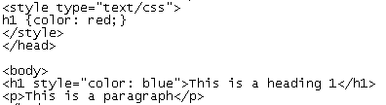

1. What style would be in effect for p element given the following code:

Embedded style

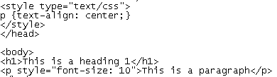

1. Write the HTML statement to link to an external style sheet named style.css, which is located in the styles sub-folder. The styles folder is a sub-folder of the folder containing the web page.

<link type="text/css" href="style.css">

1. Write the style rule that selects <ol> elements only when they appear within <p> elements and sets the font-family property to monospace.

ol, p {font-family: monospace}

**Part B – Coding**

1. Open the file highlighter.html from Part_B of the folder you copied at the beginning of the lab. The document body contains a single paragraph from Leo Tolstoy’s *Anna Karenina*. Use an embedded style sheet to create a class called highlight; the class sets the background colour to yellow. Use this class and span tag to add the yellow highlighting shown in the following image:

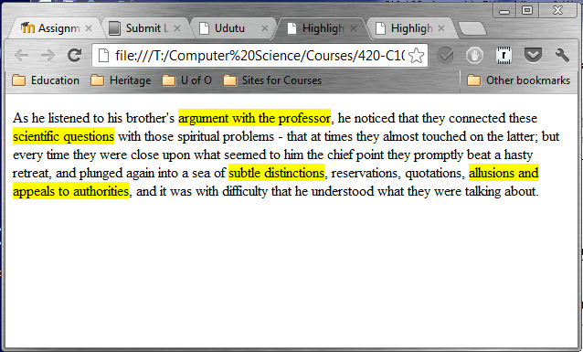

**Part C – The Hitchhikers Guide to the Galaxy**

All the files in this section are from the Part_C folder of the folder you created at the beginning of the lab.

1. Open the file hikers1.html.
2. Create an external stylesheet called hikers.css with CSS as follows:
   1. Add a style rule for the <h3> element to set the text-align property to right and the color property to gray.
   2. Add a style rule for the <h1> and <h2> elements to set the margin-left property to 20px and the font-family property to be sans-serif.
   3. Add a style rule for the <h1> element to set the border property to 1px solid and the padding property to 5px (border: 1px solid black)
   4. Add a style rule for the <p> element to set the margin-left property to 20px, the font-family property to serif, and the font-size property to 14pt.
3. Save the file. View the hikers1.html page in the browser. Make any changes required so that it looks as follows:

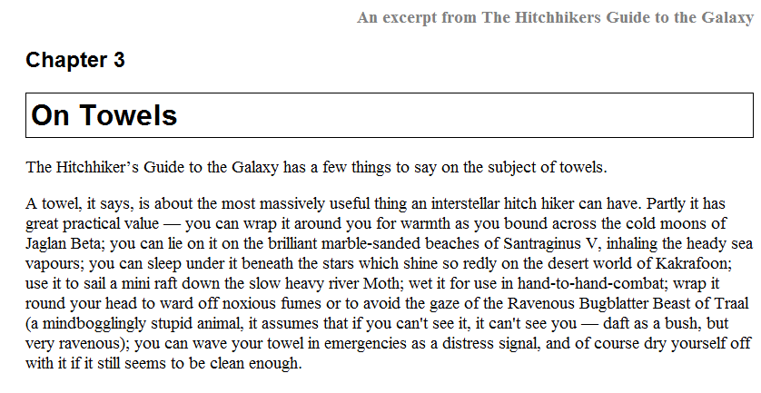

1. Open the file hikers2.html.
2. Attach the stylesheet hikers.css to this sheet and save the file.
3. View the hikers2.html page in the browser. Make any changes required so that it looks the same as hikers1.html.
4. Open the file hikers3.html.
5. Attach the stylesheet hikers.css to this sheet and save the file.
6. View the hikers3.html page in the browser. Make any changes required so that it has the same look as hikers2.html.
7. Add a style rule for a class selector named **italic** with the font-style property set to italic.
8. In all three files, apply the class by adding a class attribute **italic** to the h1 and h2 elements.
9. In hikers2.html and hikers3.html, add <span> elements around all the direct quotes and give them the class italic, e.g. <span class="italic">"We're safe,"</span>. The hikers2.html page should look as follows:

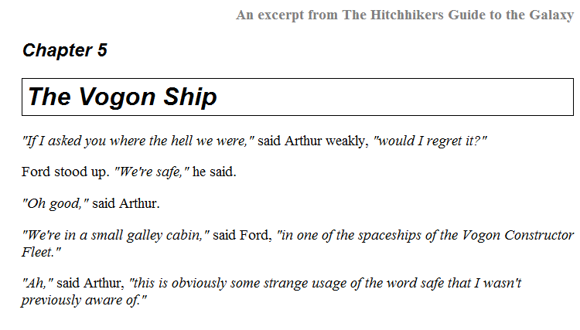

The hikers3.html page should look like this:

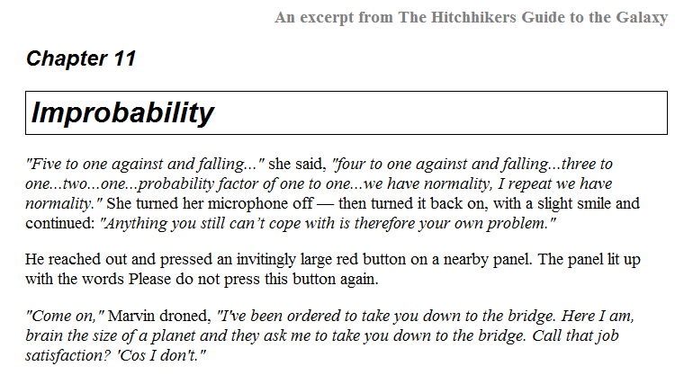

Remember to validate both the CSS and HTML using the appropriate validators. These are html5 documents…so validate them appropriately.

**Part D – Fish Creek Animal Hospital Case Study**

Complete the Fish Creek Animal Hospital Case Study requirements on pages 124–127 of your text book. Where the first step in the Hands On Practice Case on page 124 tells you to create a folder called, you do not have to. I have included the required files in the folder Part_D that you copied at the beginning of this lab.

Remember: You MUST validate both the external CSS file and the html file using the appropriate w3c validators. It is the first thing I will do when I mark them.

**Part E –Dreamweaver Tutorials**

NOTE: You MUST complete these tutorials in room 219 or at least, use a version of Dreamweaver that matches the version in the tutorial, that is, Dreamweaver CS5.5.

1. Click on the Link “Dreamweaver Tutorial 1” on the Moodle page for the course and complete the first Dreamweaver Tutorial. If the tutorial does not start, it may be because the browser is not allowing new windows to open. You should get an error message if this is the case. Allow the browser to open windows and it should work. If you’re having problems, ask for help.

At the end of the tutorial there are three quiz questions. Use the Windows 7 Snipping Tool (Start->All Programs->Accessories->Snipping Tool) to capture the screen with the correct answers and paste it into this document.   
  
**NOTE: You must capture the screen when the message indicating that you go the correct answer is displayed. That way I can tell you completed the quiz and got the correct answer.**

Quiz #1

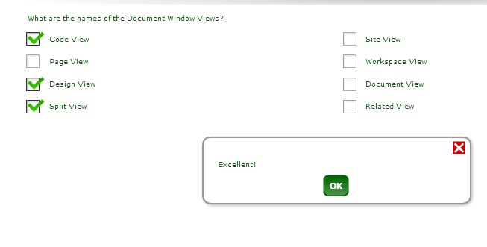

Quiz #2

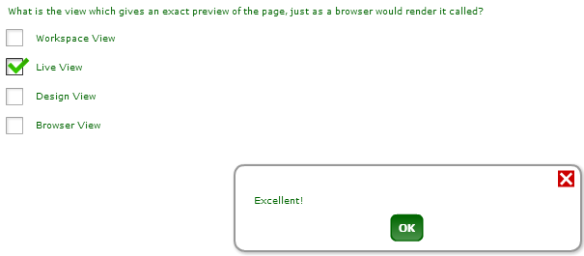

Quiz #3

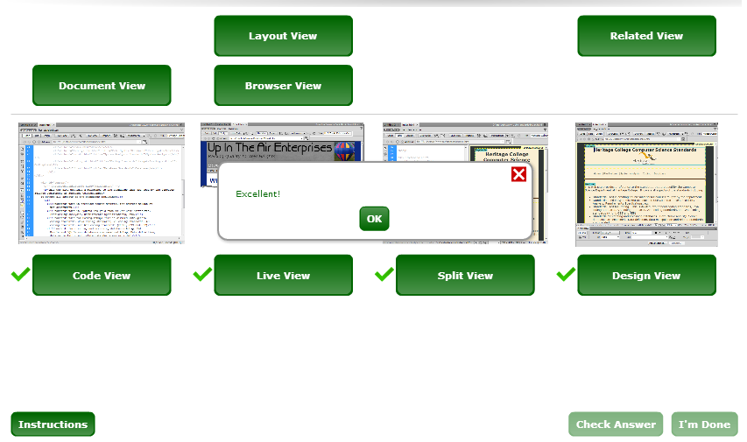

1. Click on the Link “Dreamweaver Tutorial 2” on the Moodle page for the course and complete the second Dreamweaver Tutorial.
2. Click on the Link “Dreamweaver Tutorial 3” on the Moodle page for the course and complete the third Dreamweaver Tutorial.

**To submit**

When you have completed the lab exercise, zip up the lab folder and copy it to the Moodle page for the course. The folder should contain:

* The folder YourUserName_C10_L05 with the files
  + YourUserName_C10_L05_css.pdf
  + Part_B folder and files
  + Part_C folder and files
  + Part_D folder and files
  + Part_E folder and files